Which is true of the following code?

Set<String> birds = Set.of(“…

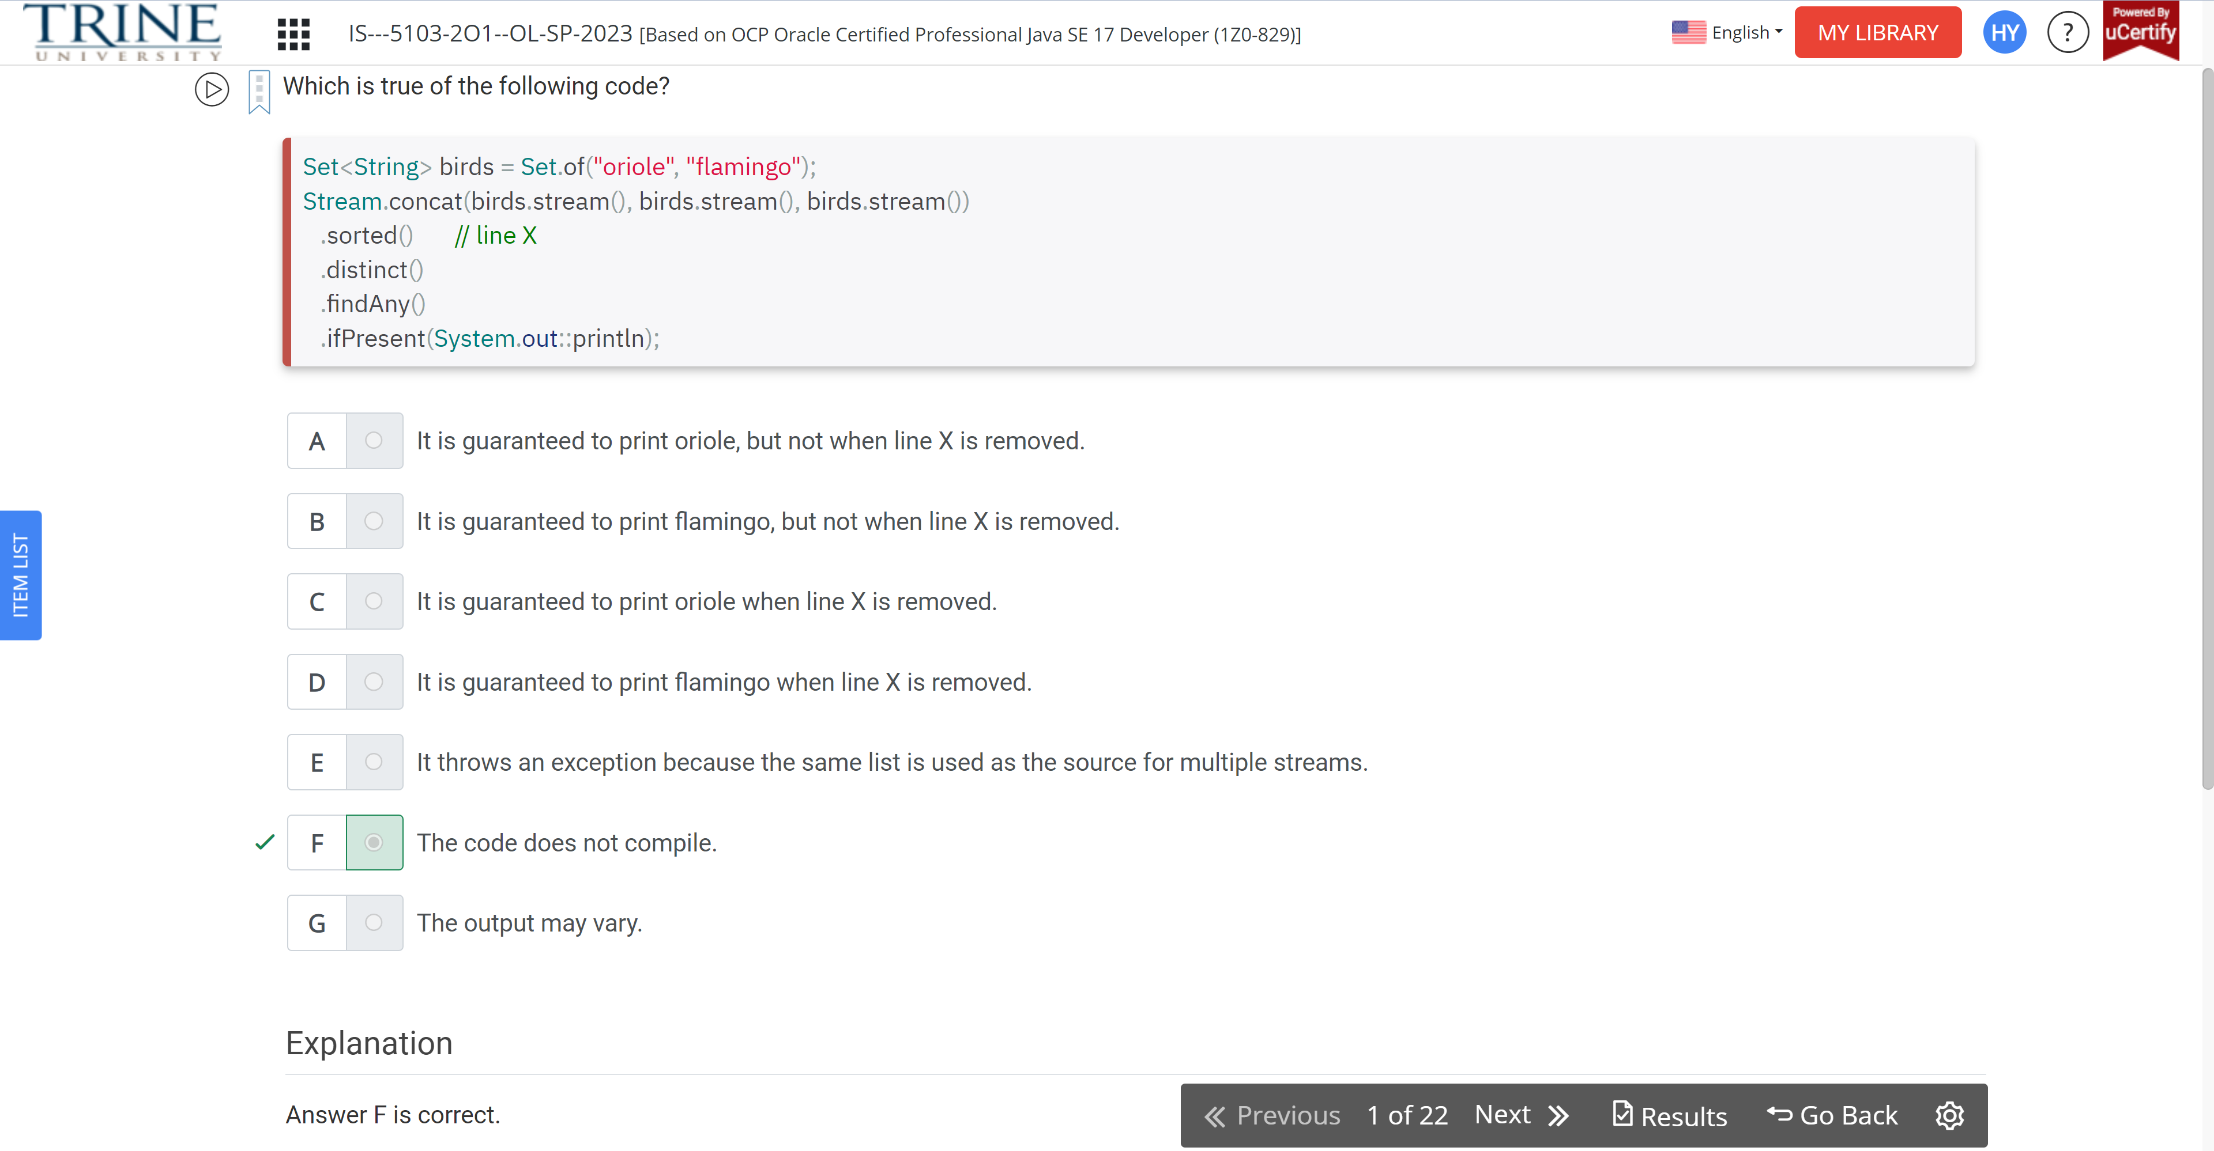

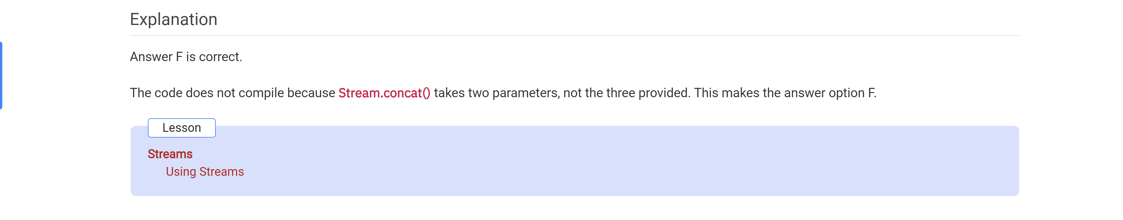

Which of the following can we add after line 3..

Var stream = LongStream..

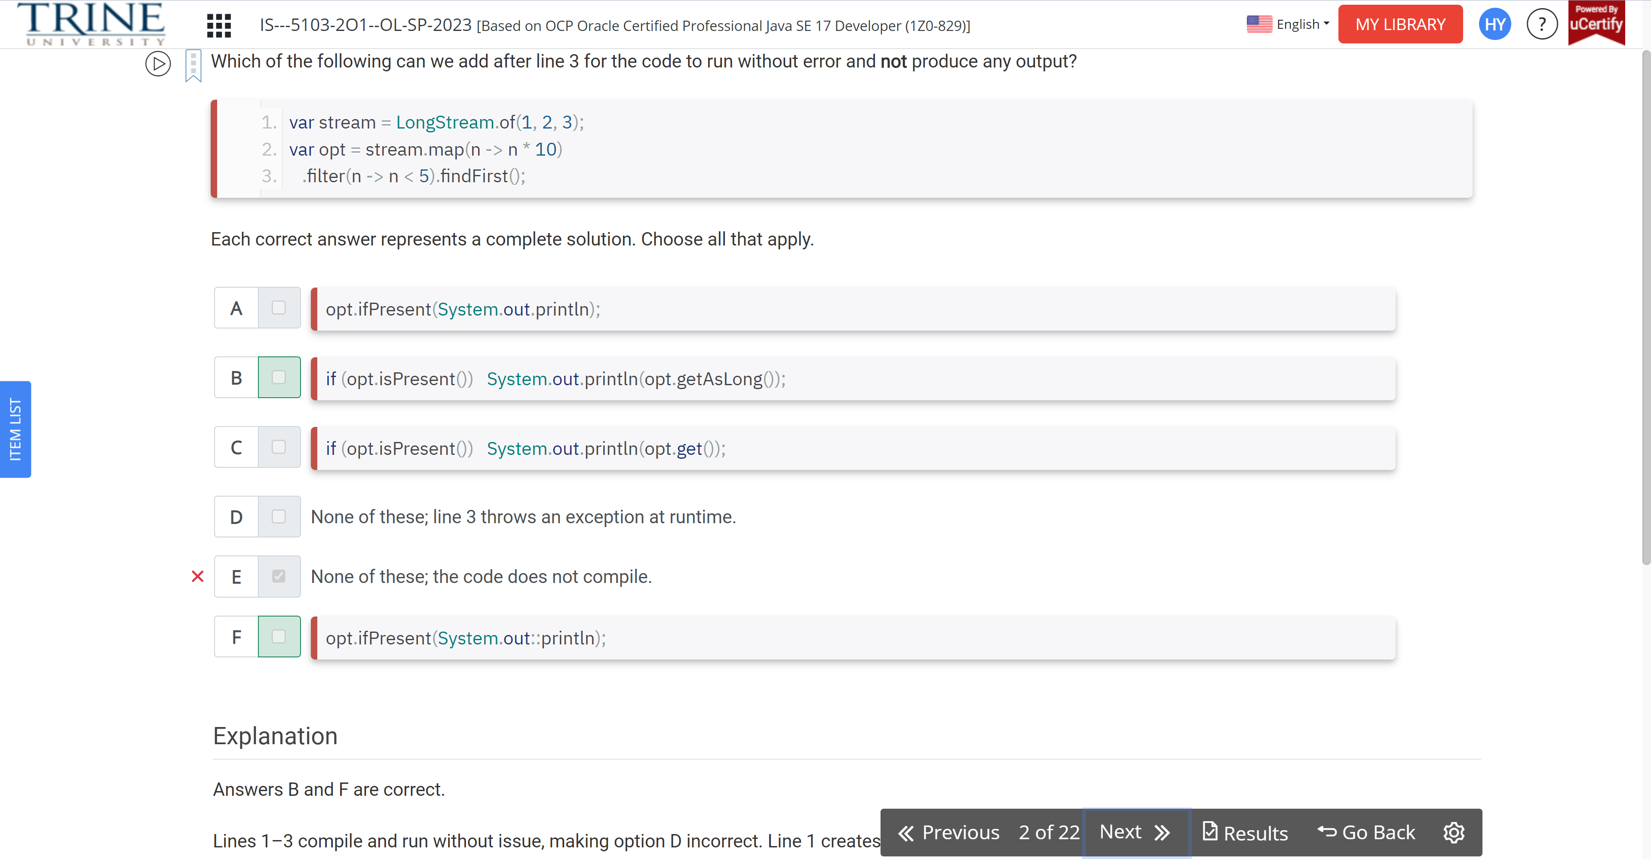

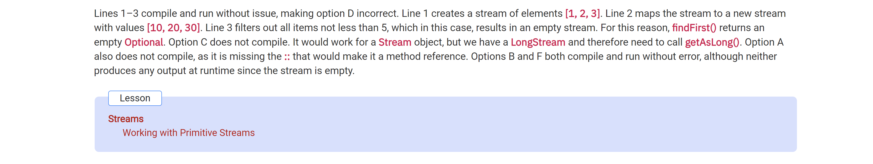

Which of the following are true?

Stream<Integer> s = Stream.of(1);

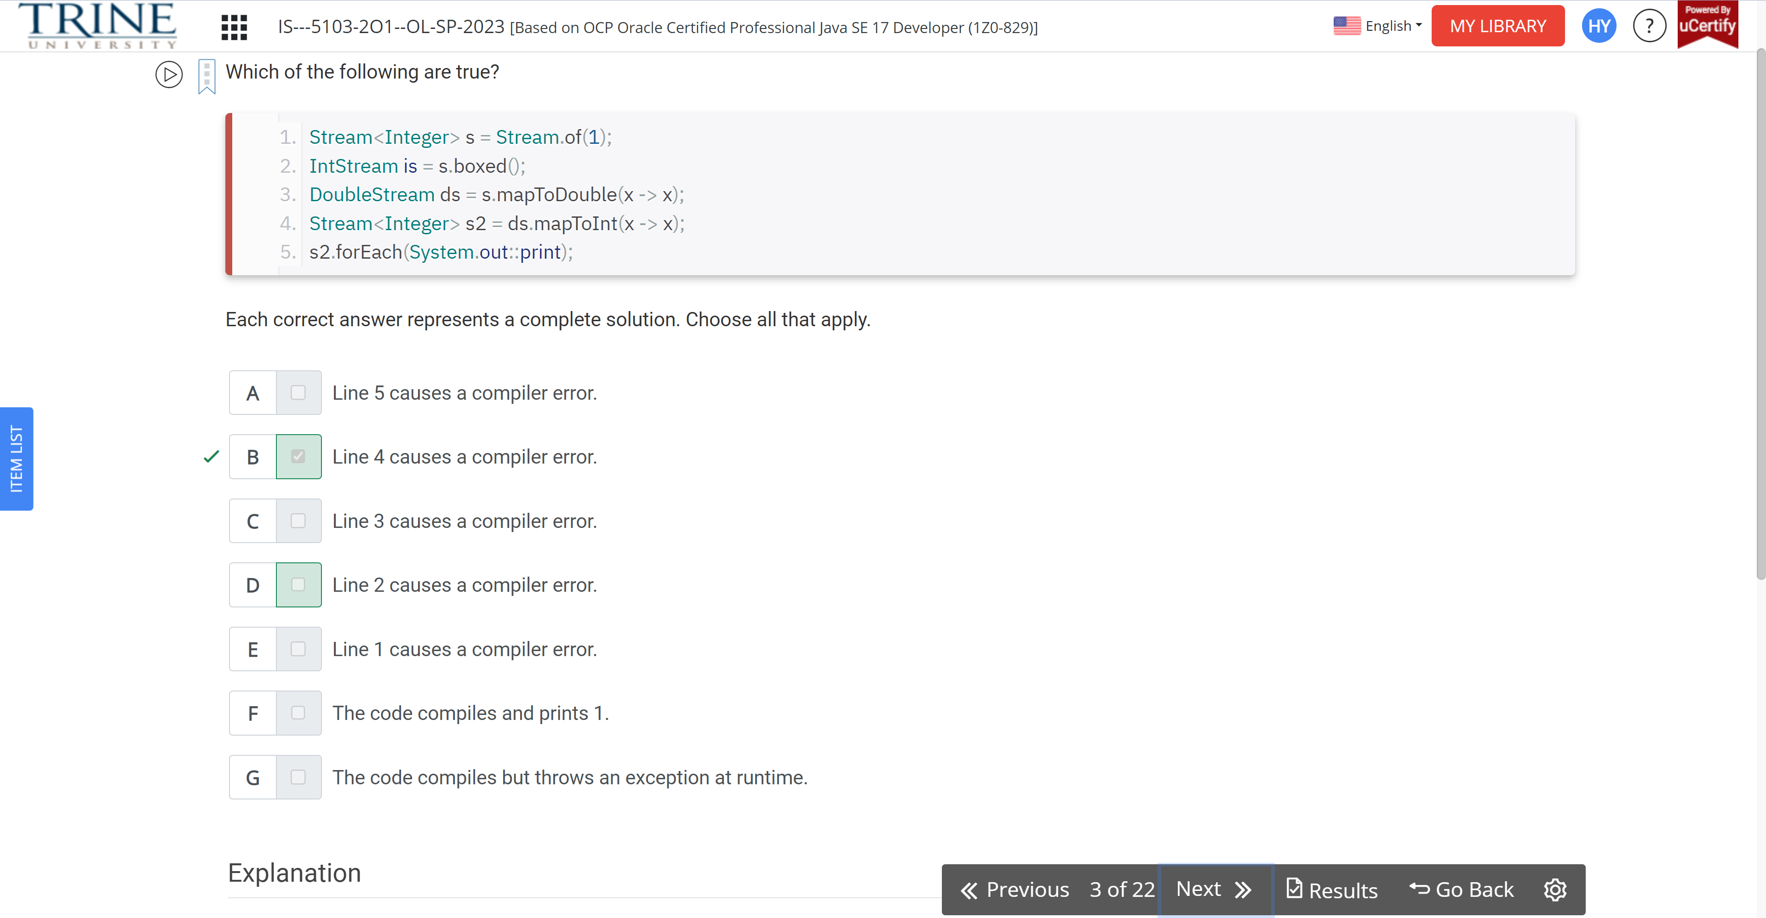

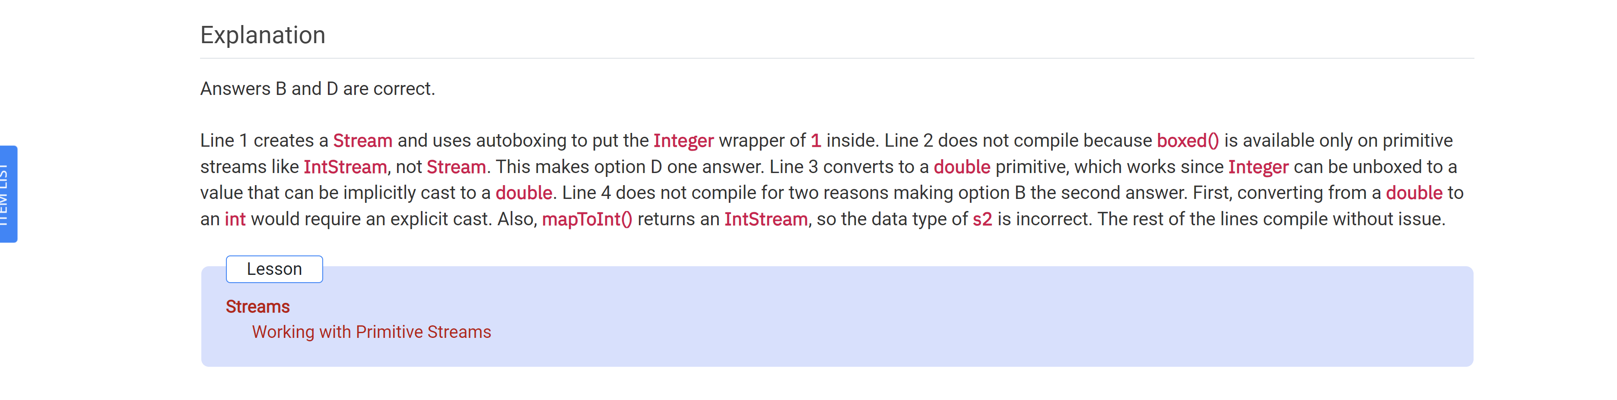

Which of the following statements are true about this code?

Predicate<String> empty = …

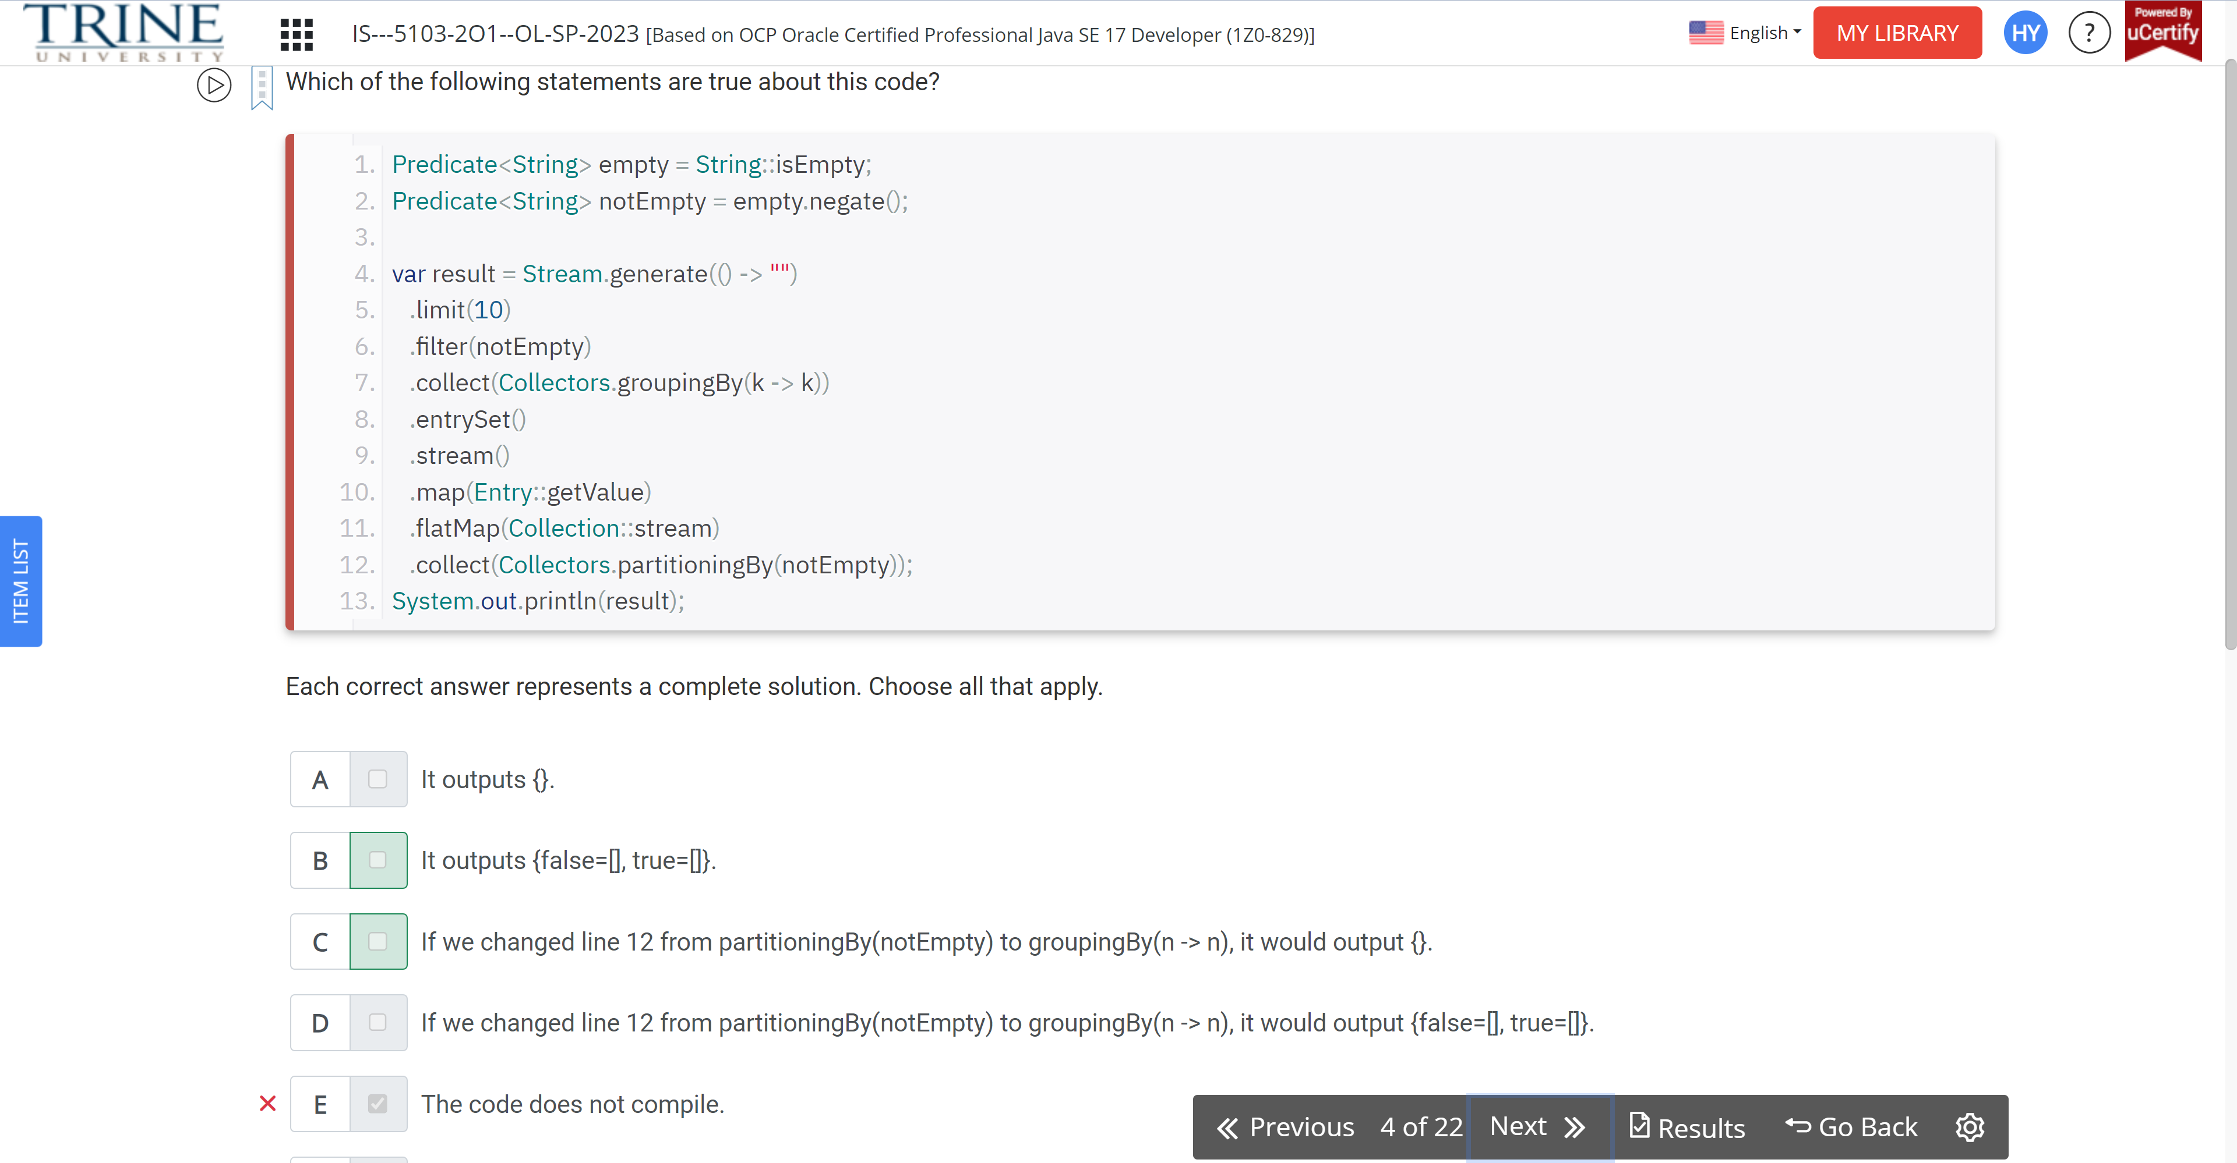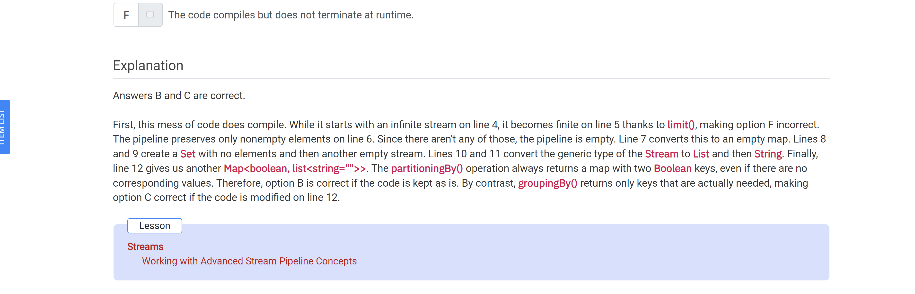

What is the simplest way of rewriting this code?

List<Integer> x = …

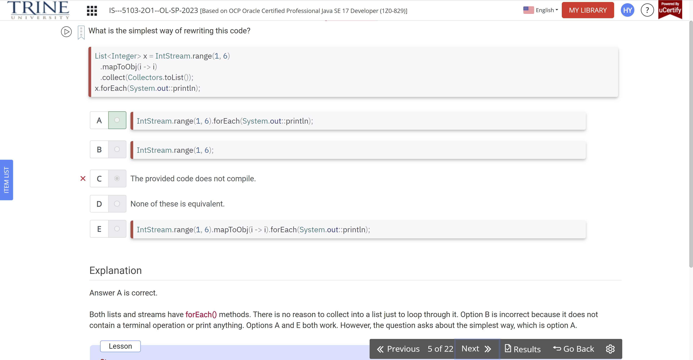

What could be the output of the following?

Predicate<String> predicate …

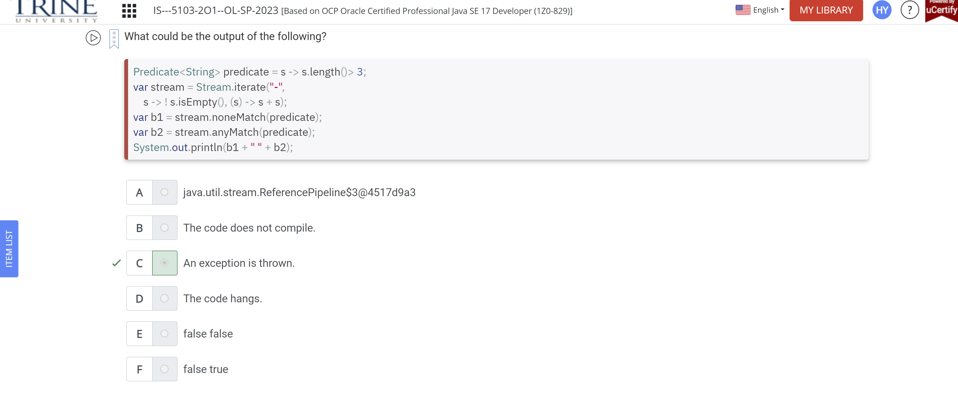

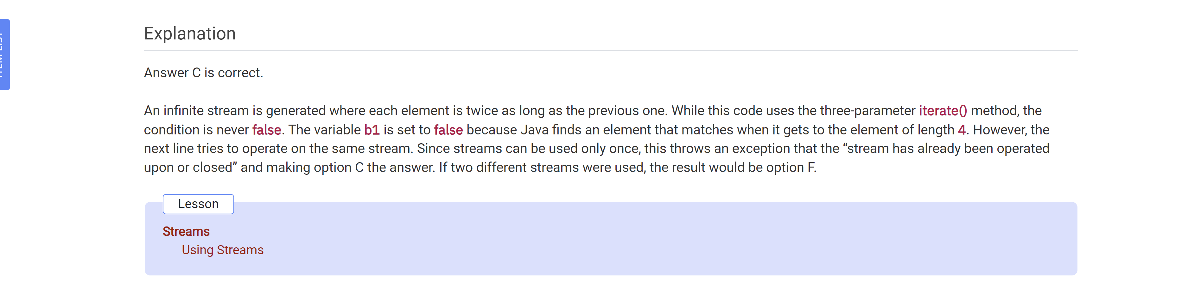

Which of the following is true?

List<Integer> x1 = …

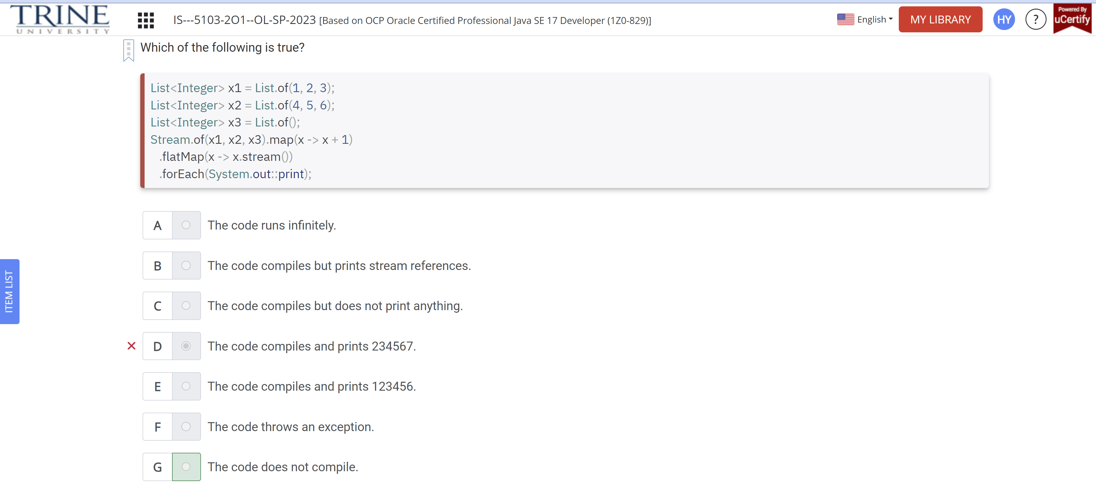

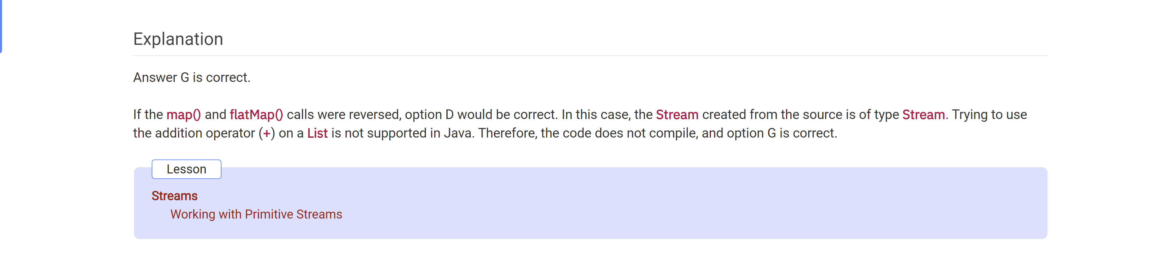

What is the output of the following?

Public class Paging…

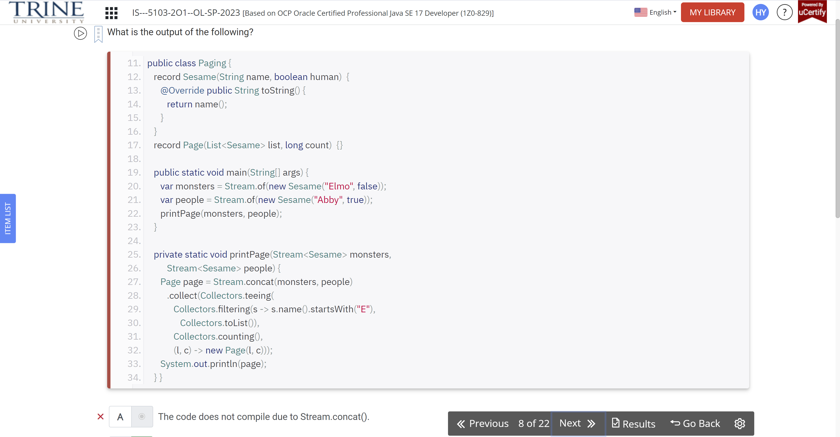

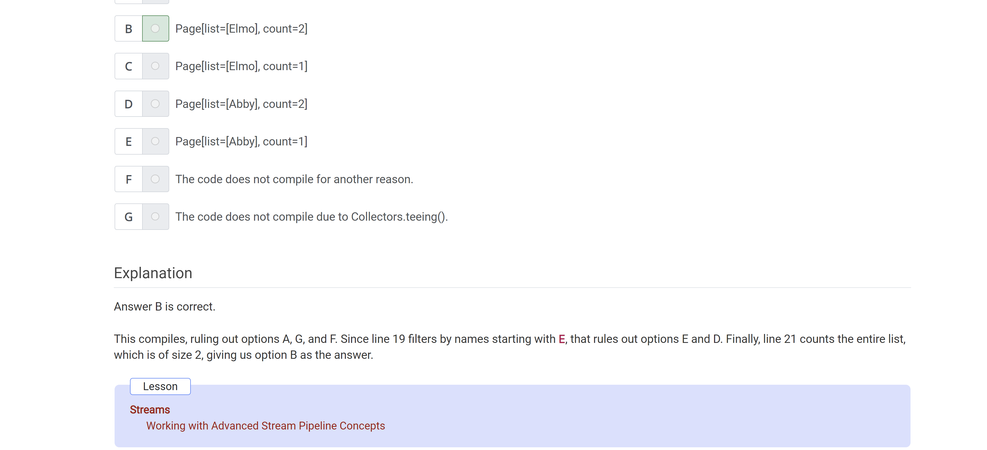

What changes need to be … 12345?

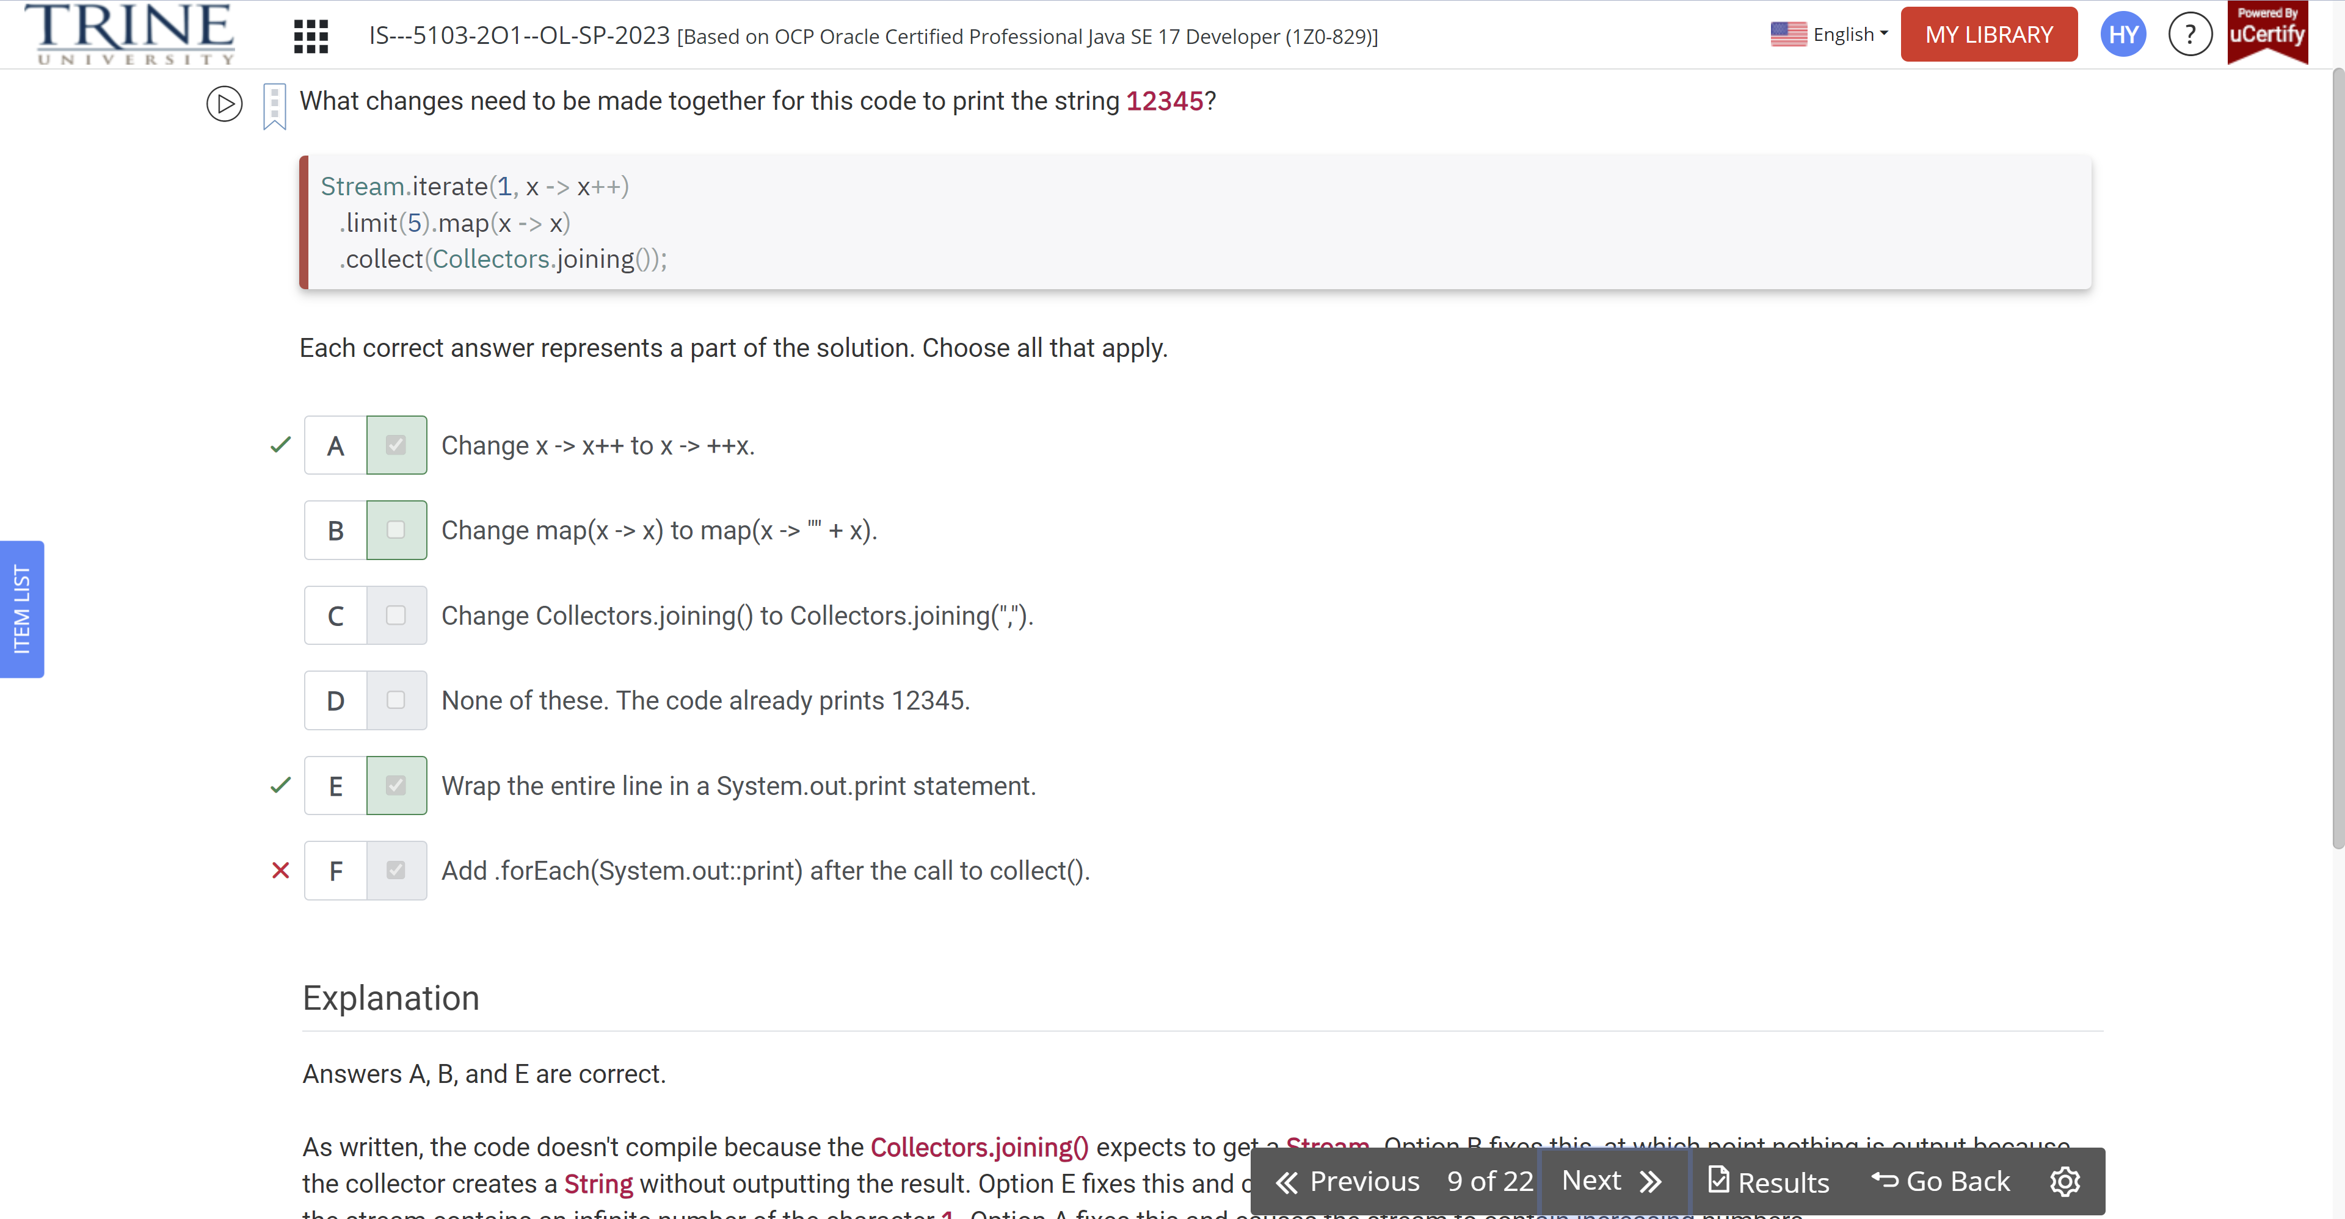

We have a method …

Private static List<String> sort …

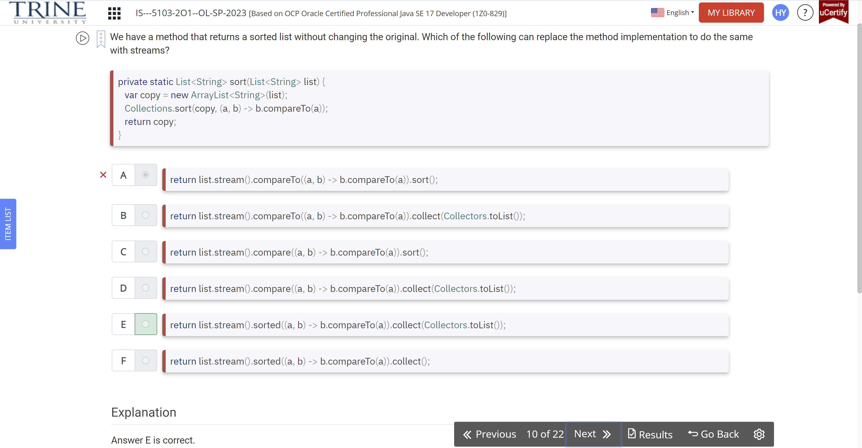

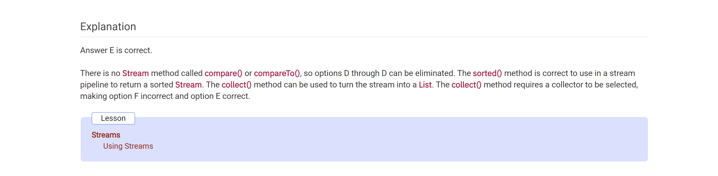

Which are true statements about terminal…

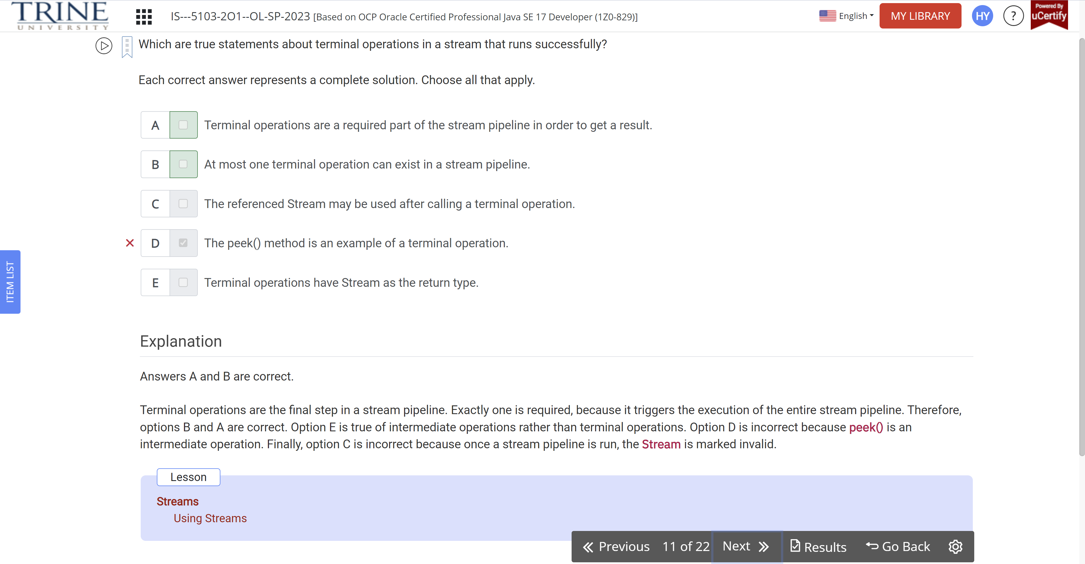

What is the output of the following code?

Var spliterator = …

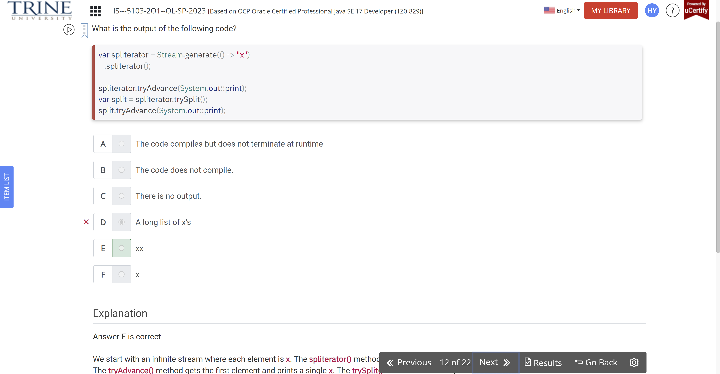

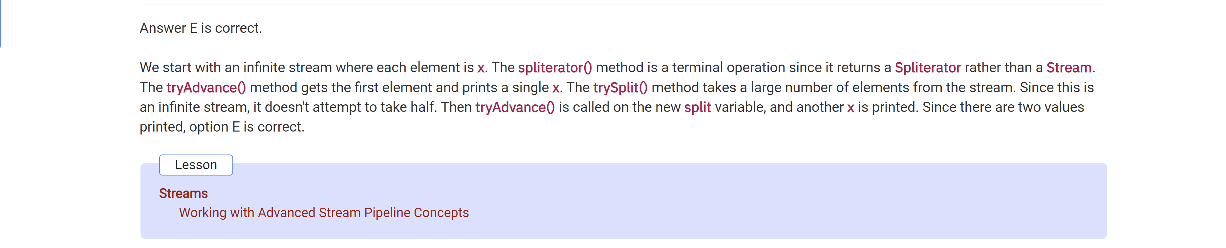

Which of the following sets result to 8.0?

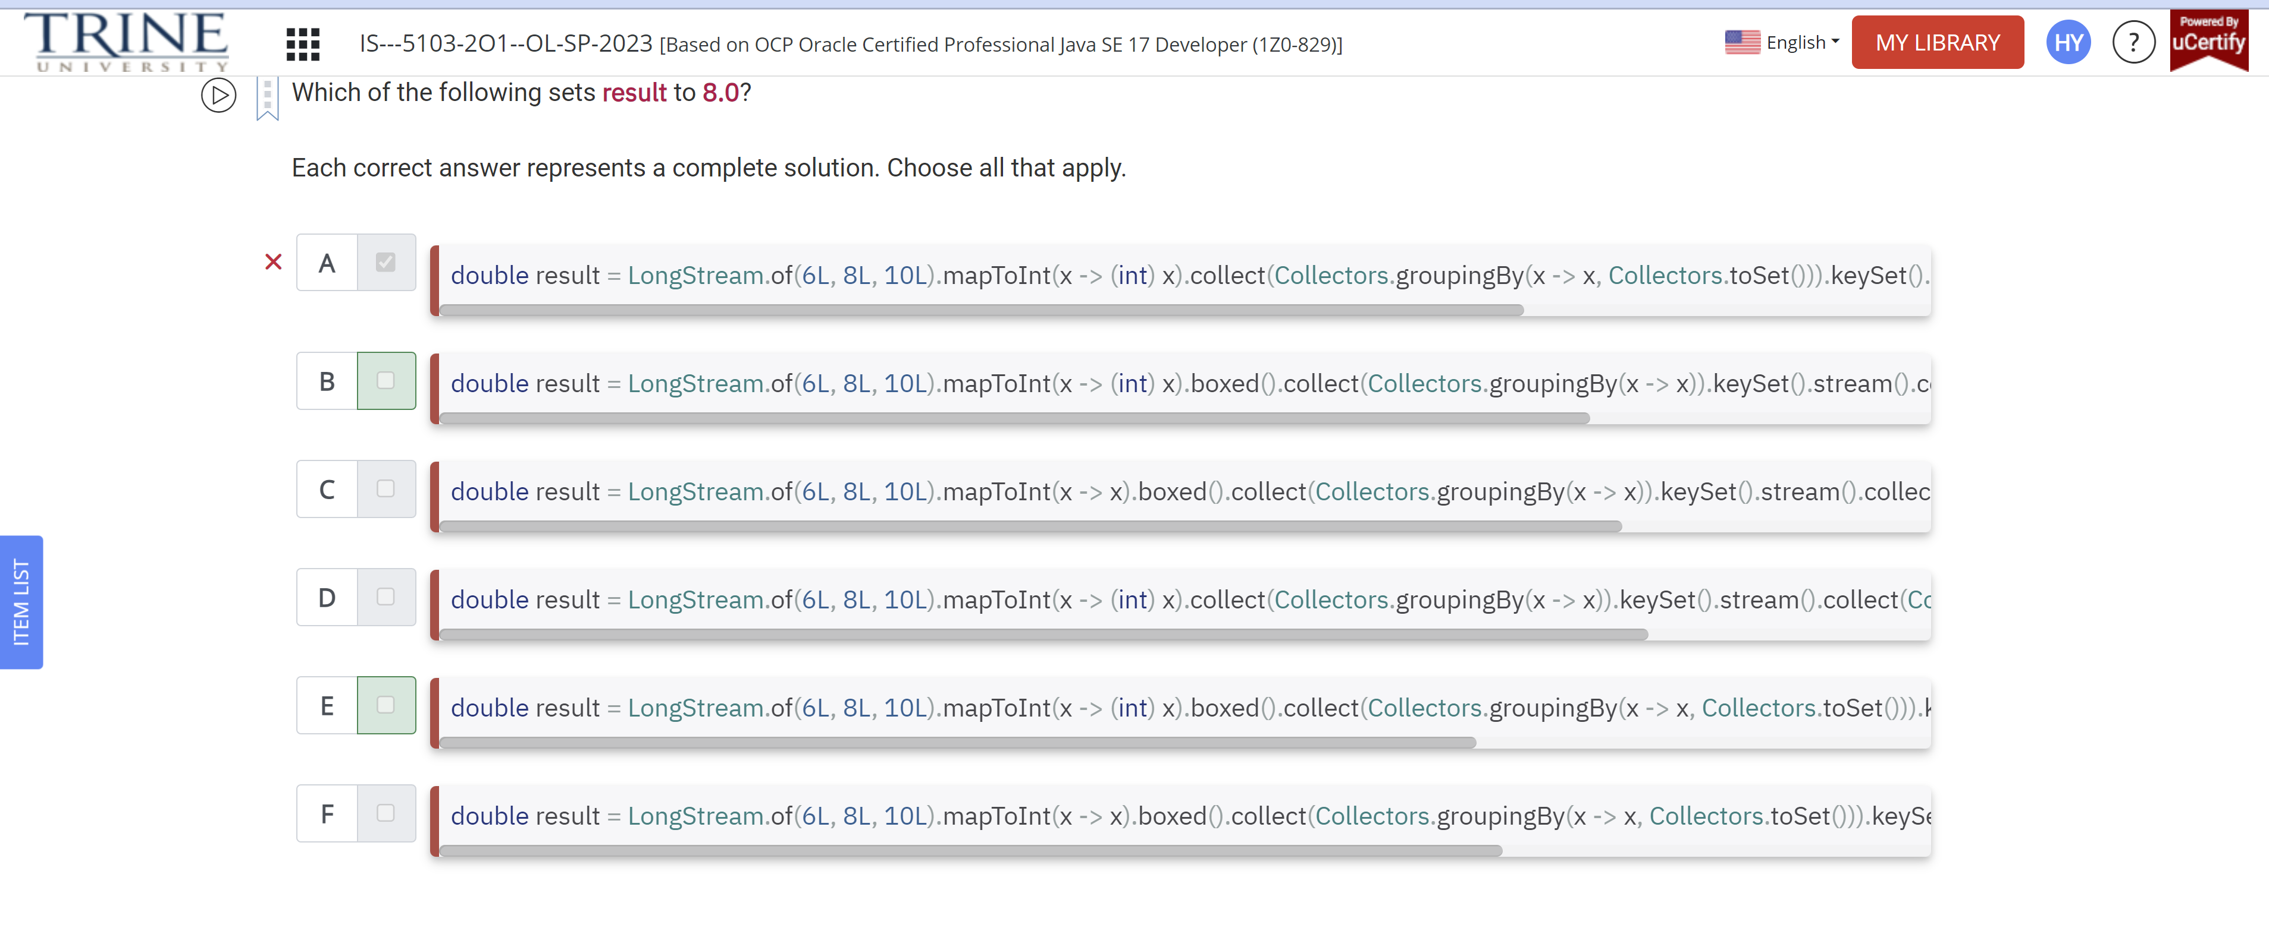

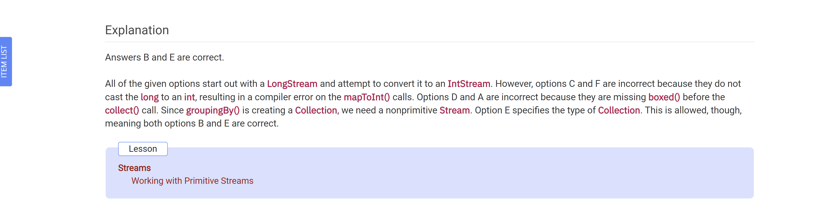

Which of the following throw an exception when an Optional is empty?

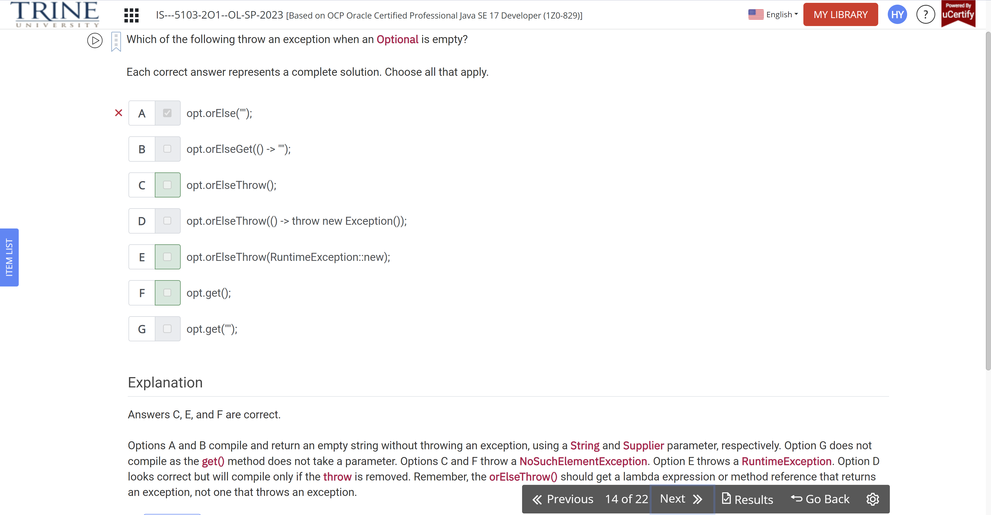

What could be the output of the following code snippet?

Var stream = …

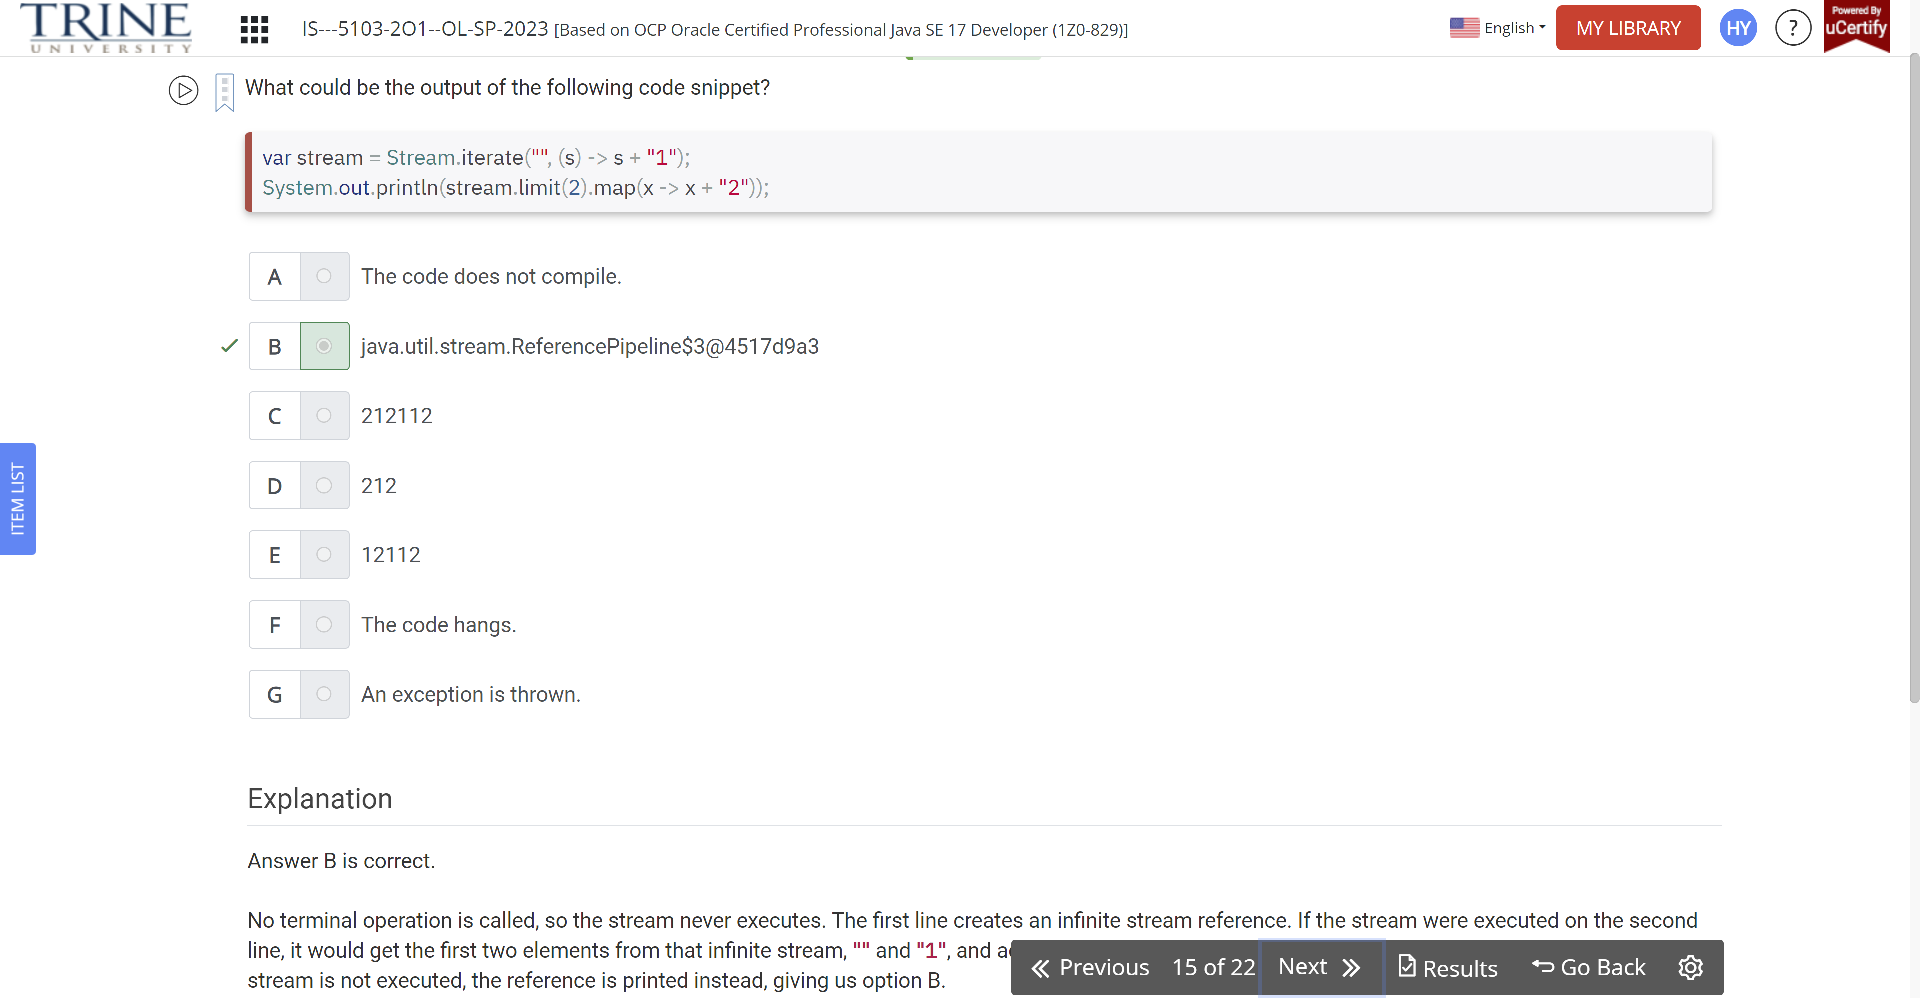

Which of the following can fill in the blank so that .. false?

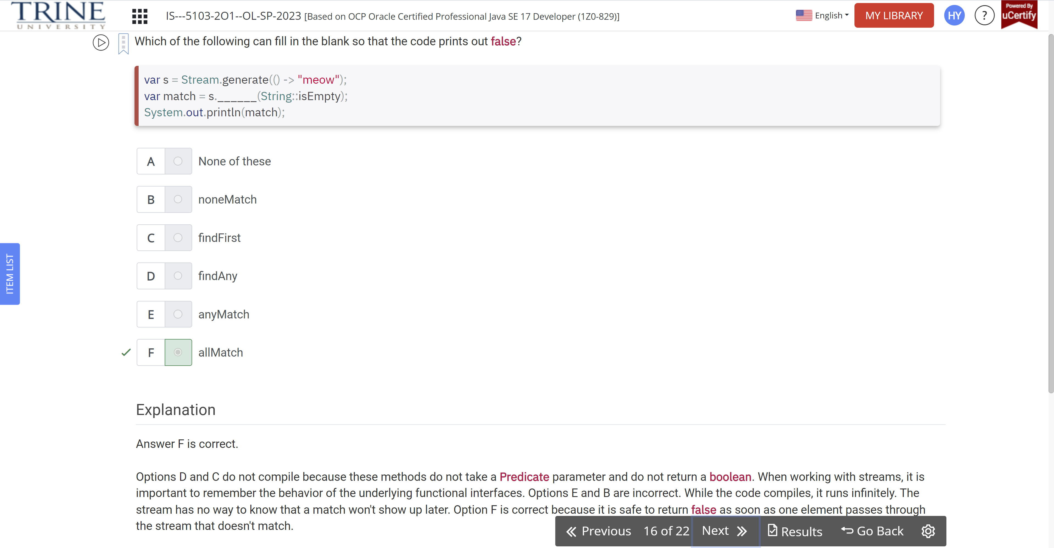

What is the result of the following code?

Var s = DoubleStream.of…

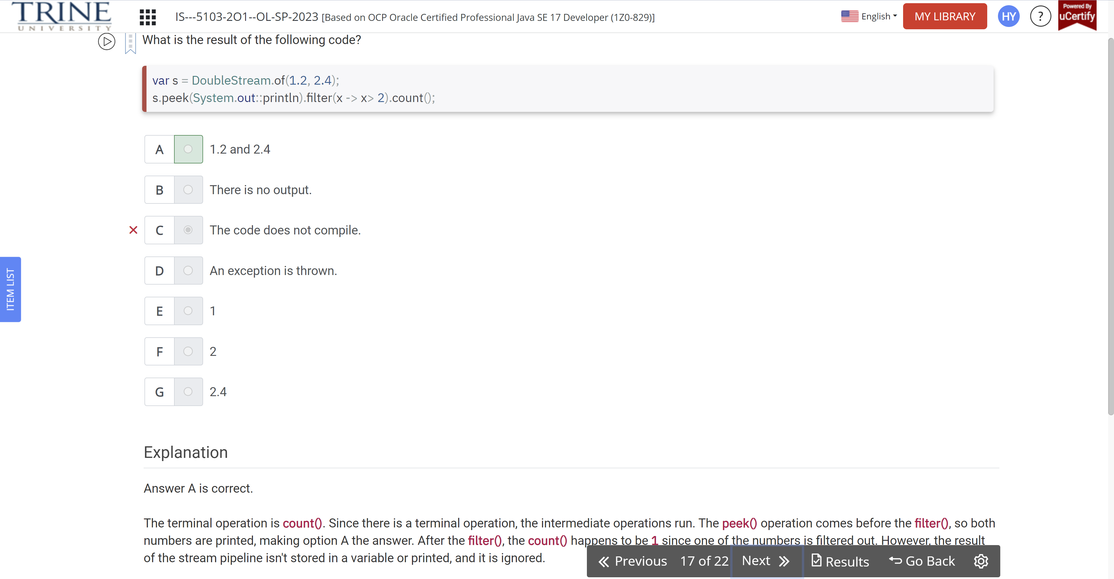

Given the four statements (L, M, N, O)…

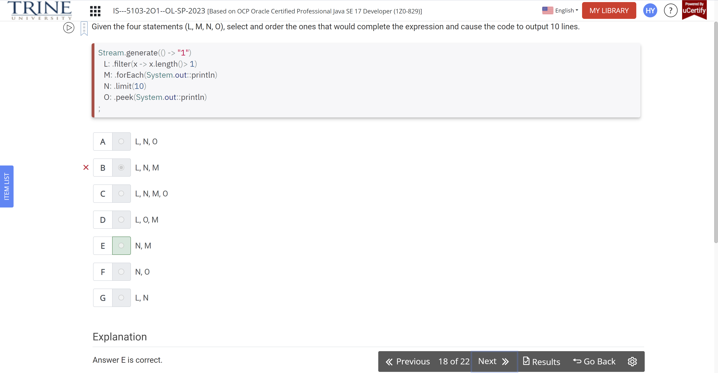

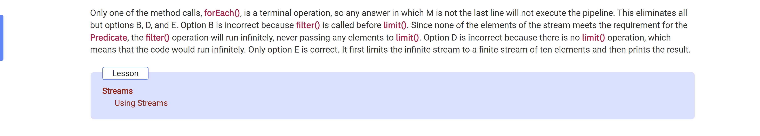

What could be the output of the following ?

Predicate<String> predicate = s -> s.startsWith…

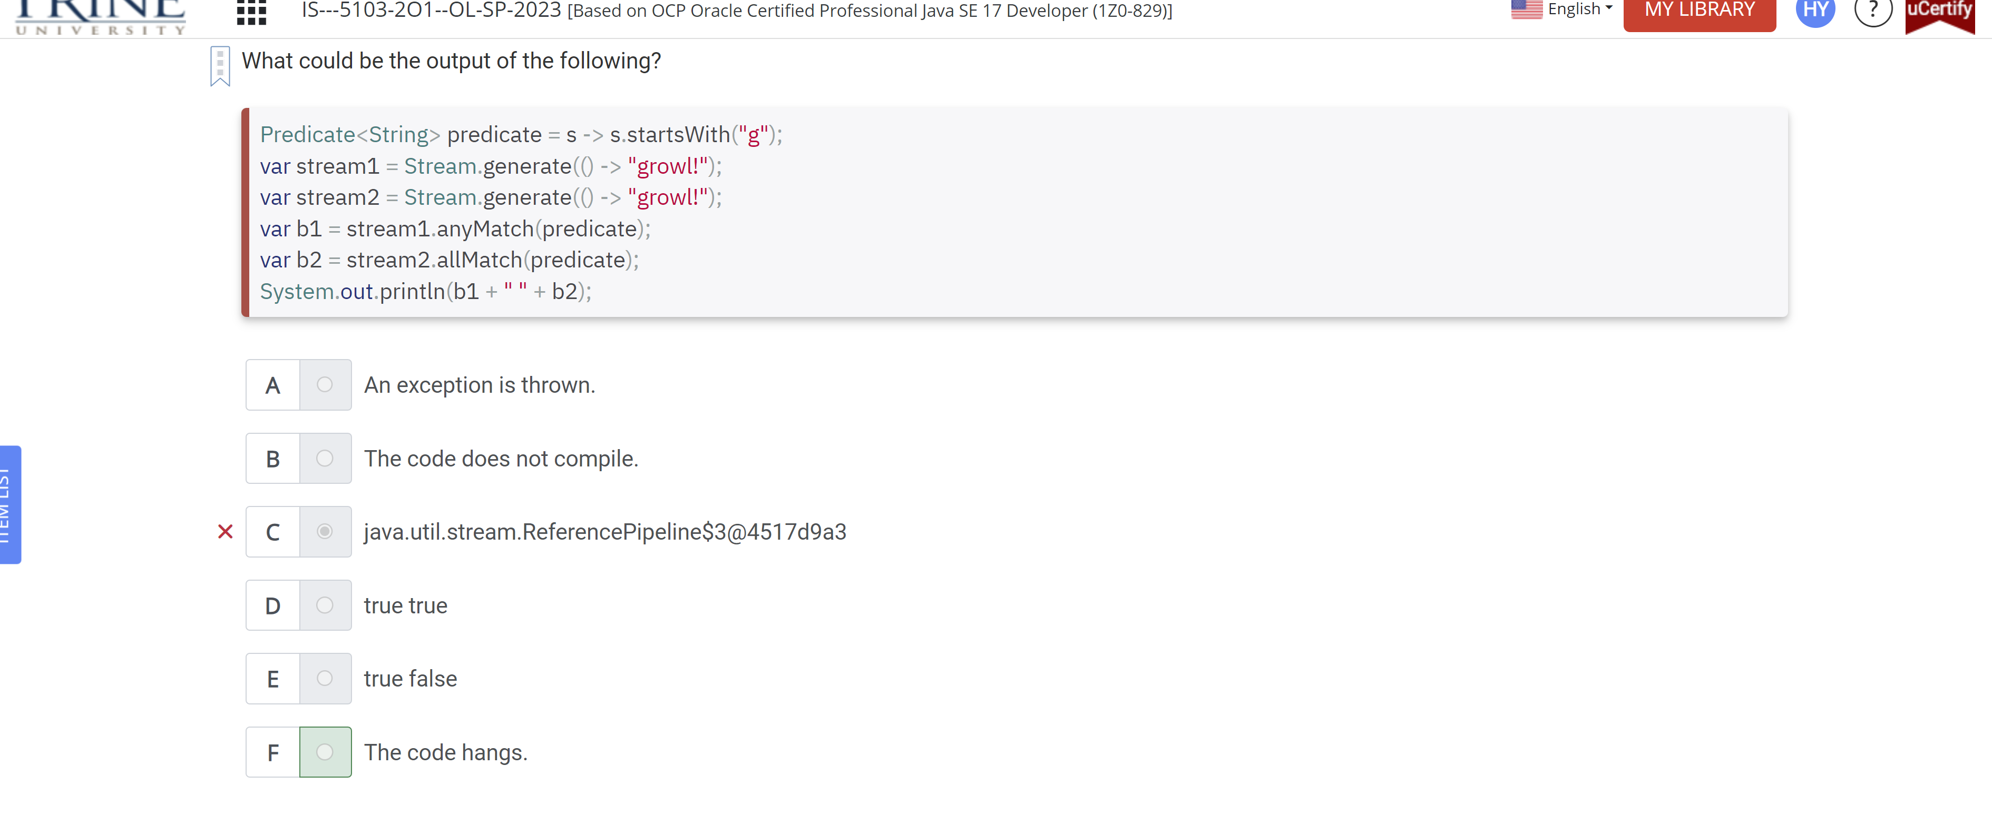

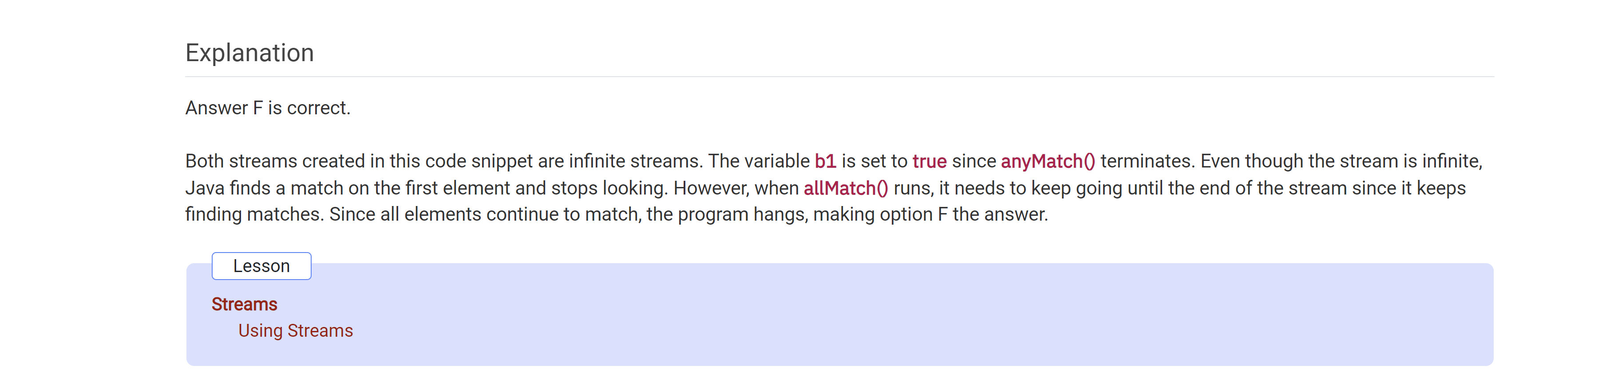

Assume that the directory /animals exists …

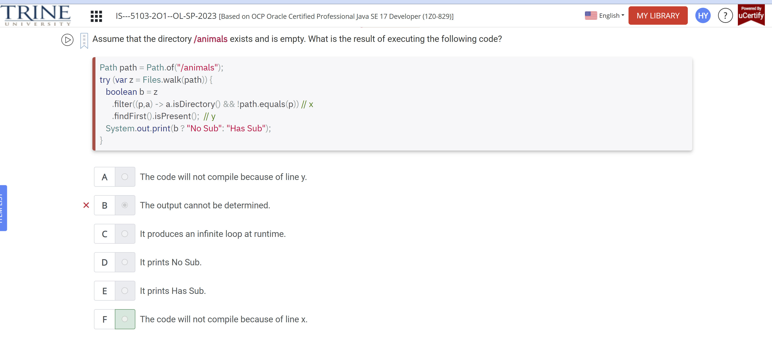

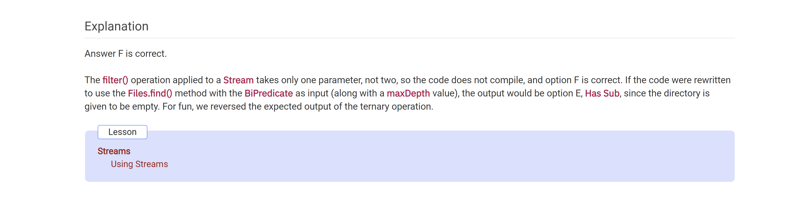

Given the generic type String, the partitioningBy()…

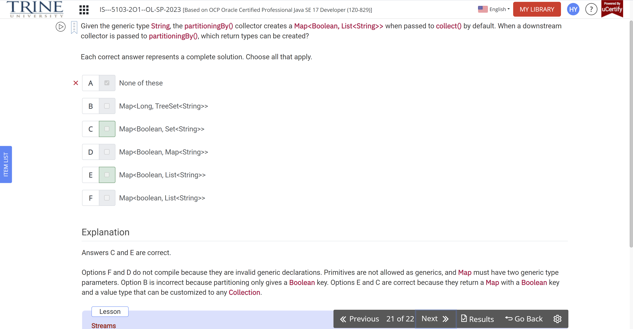

Which of the following are true

Var is = IntStream.empty();

